Getting Premium at the Cost of Regular

Whenever we fill up our cars with gas, we have a choice: we can buy “regular,” or we can pay extra (sometimes as much as 30 cents a gallon extra) for “premium” gasoline. Experts say that, for most cars, premium gas doesn’t accomplish anything except, perhaps, adding to the bonus pools of oil company executives. That’s why thrifty car owners always push the “regular” button on the self-service display.
The the bond world uses similar terminology. You can buy a “premium” bond, which means you’re paying more than the original offering price--in other words, more than you’ll get back when the bond matures. Or you can buy bonds at par. For instance, you might see bond tables which show that a newly-issued 5-year bond is selling for $100, so if you invested (to keep the numbers round) $1 million in this bond, you’ll get back $1 million at the end of five years, plus five annual coupon payments at the bond’s original interest rate. Another bond with a 5-year maturity, with the same face amount of $100, is being sold for $109.16. You pay $1,091,600 for the bond and get back $1 million at the end of the term.
Being a thrifty investor, you would be careful only to push the “par” button whenever you buy on the bond market. Right?
Unfortunately, bond terminology doesn’t always make the kind of common sense we encounter in the real world. The truth is, premium bonds normally cost exactly the same as bonds sold at par.
How is that possible? The difference lies in the amount and timing of the coupon payments. If you take a closer look at those two 5-year bonds, you discover that the one at par is paying interest at today’s market rate of (again, keeping the numbers found) 3%. The reason investors are willing to pay a “premium” for the second bond is because it’s offering a higher 5% yield.
How can you compare the two? The par bond will pay you $30,000 (3% of $1 million) for five years, which comes to $150,000. If you were to reinvest the money each year at the same current 3% rate, you’d get an additional $9,274 in interest. Add the coupon payments and the reinvestment amount to the $1 million you get back when the bond matures, and the total comes to $1,159,274.
Now consider the premium bond, where you’re paying more than par up-front, enough more so that your $1 million will only buy of $916,091 worth of paper. But each year, you get $45,804 in coupon payments (5% times the face amount), for a total of $229,023. If you reinvest those payments at the current 3% interest rates, you will receive an additional $14,160. Add up $916,092, $229,023 and $14,160--and presto! The total comes to exactly the same $1,159,274 that you would have received from the bond that was sold at par. (You can see the comparison in the accompanying chart, courtesy of Performance Trust Company, a bond market research firm in Chicago.)

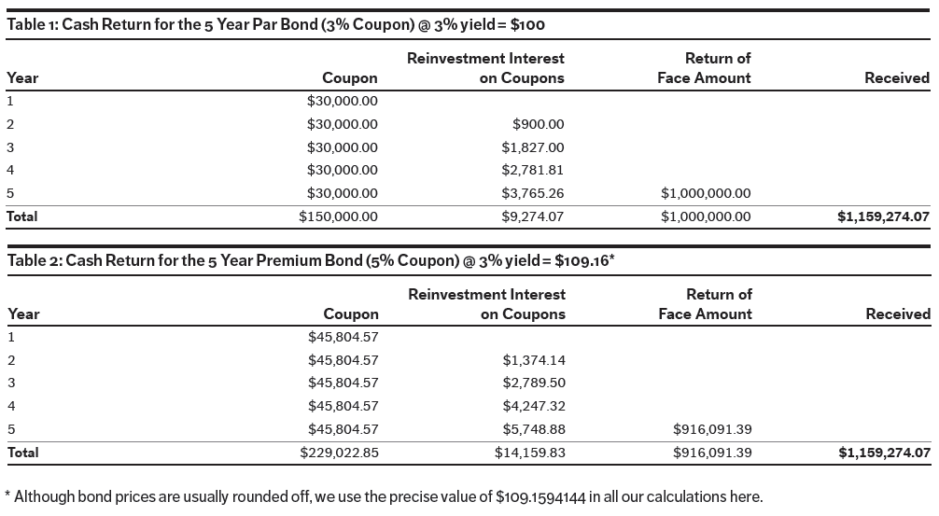

So why would serious bond investors, armed with bond calculators which can tame these numbers down to the penny, buy one or the other? There are two reasons. First, since interest rates have mostly been falling since the early 1980s, most bonds on the market today happen to be premium bonds; that is, they were issued at a time when coupon payments were higher than today’s market rate.
The second reason is more interesting. Premium bonds offer an advantage during periods when interest rates are rising--which many people worry about, given today’s historically low rates, especially if the Federal Reserve Board decides to stop stimulating the economy at some point in the future.
Remember, the calculations you saw earlier assumed that you would reinvest your coupon payments at a steady 3% rate. If rates in the second year happened to be higher, and still higher in the third and subsequent years, the bottom line for both the par bond and the premium bond will be a bit higher. But the premium bond would outpace the par bond because more money--the higher coupon payment--is being reinvested at those higher rates. You can get a peek at how this would affect the investor’s total return in the table below (also courtesy of Performance Trust).

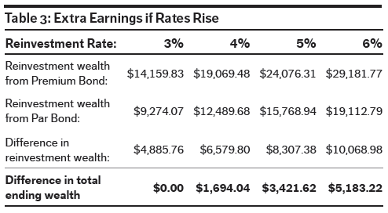

The bottom line? Don’t be put off by the terminology. A premium bond actually costs the same as a par bond--which is very different from premium gas, or premium seating or a lot of other things where you’re paying more for something of dubious additional value. You can buy premium bonds and still be thrifty, and smart, and perhaps even a bit wealthier if interest rates happen to rise in the months and years ahead.

